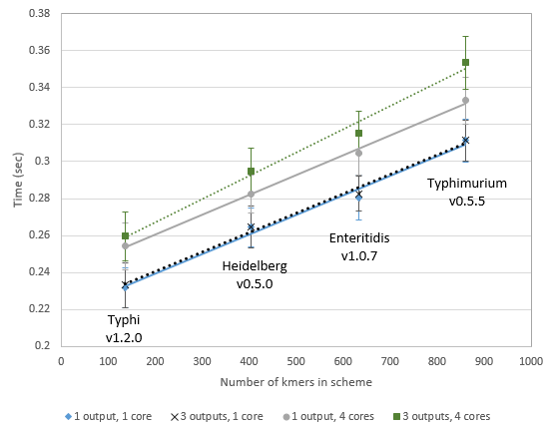

Figure S5.  Runtime per assembly per core for different schemes, using 1 or 4 cores on a personal computer, specifying either 1 or 3 outputs.   Each point represents an average runtime calculated from runs done on 250-1000 assemblies (n=40).